**WEEK - 1**

**Introduction to Decision Support Systems**

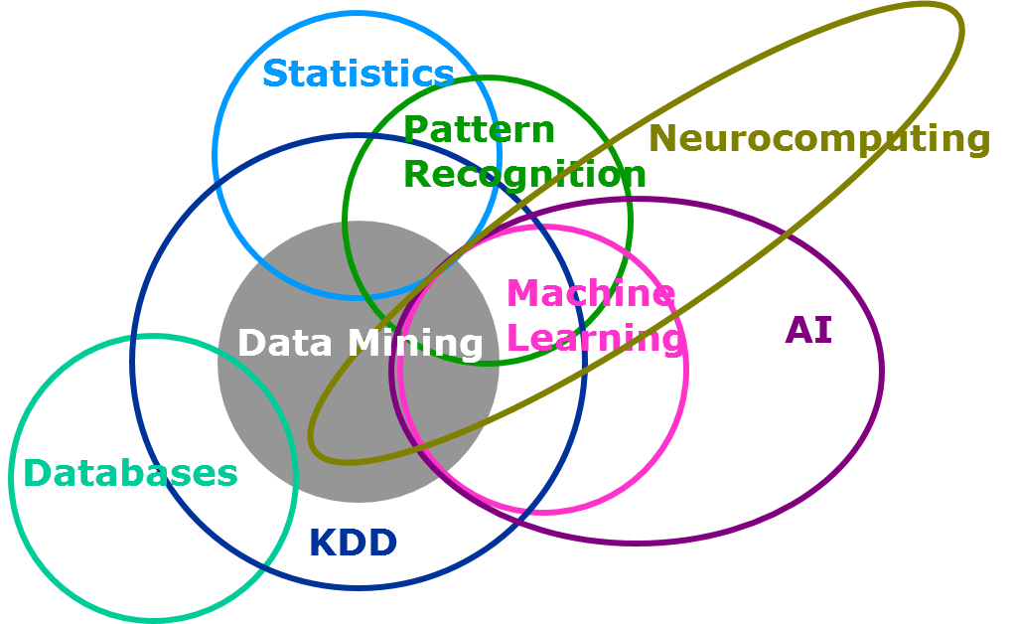

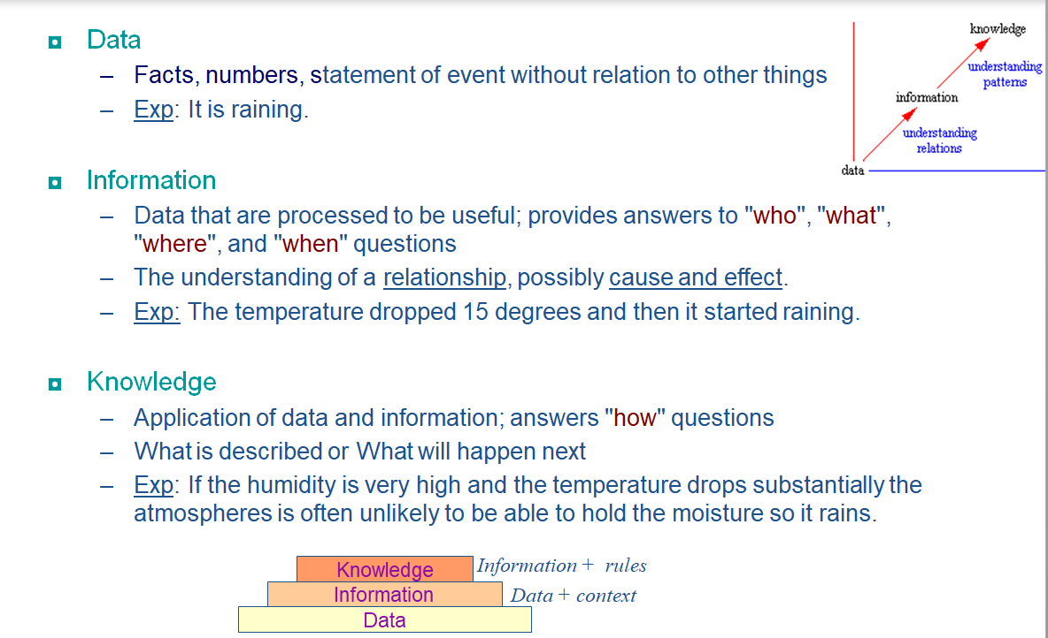

**Decision is**

a choice made between alternative courses of action in a situation of uncertainty, certainty or risk.

**The theory of optimal and satisfactory decisions.**

The assumptions of the model:

* The individual knows all the available alternatives
* He knows he is fundamentally familiar with their results.
* If he can determine the preference-ranking of the results, the selection of the optimal alternative is, in theory, an easy task.

Optimal and satisfactory decisions can be either of two types:

* The principle of objective rationality: if pre-conditions are actually delivered
* The principle of limited rationality: in formulating, and solving complex problems the capacity of the human mind is very small compared to the size of the problems emerging in real-life situations to solve problems on the basis of objective rationality.

The theory suggests the following as the bases of the decisions:

* Instead of maximality, the individual aims at a satisfactory solution by selecting a satisfactory alternative

The decision maker studies and examines the possible alternatives until he finds the one that satisfies minimal requirements.

**Decision-making under Certainty:**

A condition of certainty exists when the decision-maker knows with reasonable certainty what the alternatives are, what conditions are associated with each alternative, and the outcome of each alternative.

Under conditions of certainty, accurate, measurable, and reliable information on which to base decisions is available.

The cause and effect relationships are known and the future is highly predictable under conditions of certainty.

Such conditions exist in case of routine and repetitive decisions concerning the day-to-day operations of the business.

**Decision-making under Risk:**

When a manager lacks perfect information or whenever an information asymmetry exists, risk arises.

Under a state of risk, the decision maker has incomplete information about available alternatives but has a good idea of the probability of outcomes for each alternative.

While making decisions under a state of risk, managers must determine the probability associated with each alternative on the basis of the available information and his experience.

**Decision-making under Uncertainty:**

Most significant decisions made in today’s complex environment are formulated under a state of uncertainty.

Conditions of uncertainty exist when the future environment is unpredictable and everything is in a state of flux.

The decision-maker is not aware of all available alternatives, the risks associated with each, and the consequences of each alternative or their probabilities.

The manager does not possess complete information about the alternatives and whatever information is available, may not be completely reliable.

In the face of such uncertainty, managers need to make certain assumptions about the situation in order to provide a reasonable framework for decision-making.

They have to depend upon their judgment and experience for making decisions.

**Decision making is**

The thought process of selecting a logical choice from the available options.

When trying to make a good decision, a person must weight the positives and negatives of each option, and consider all the alternatives.

For effective decision making, a person must be able to forecast the outcome of each option as well, and based on all these items, determine which option is the best for that particular situation.

**DECISION SUPPORT SYSTEMS**

**Decision support systems (DSS) are defined as interactive computer-based information systems intended to help decision makers utilize data and models in order to identify and solve problems, and make decisions.**

In contrast with decision analysis and operational research, where the emphasis is on making and using decision models, DSS focus on providing information technology for decision makers at various levels in organisations.

The emphasis is on providing relevant information and presenting it in a suitable form so as to improve the decision making process and tasks.

The main characteristics of DSS are:

• DSS incorporate both data and models,

• they are designed to assist managers in their decision processes in semi-structured or unstructured decision-making tasks,

• they support, rather than replace, managerial judgment,

• their objective is to improve the quality and effectiveness (rather than efficiency) of decision making.

DSS can support decision makers in a number of different ways.

They can store data and provide means to search for relevant data items.

More advanced techniques include query languages and data warehouses.

Data can be viewed and analysed using pivot tables and other methods of on-line analytical processing (OLAP).

DSS can provide computational and statistical models, for instance for trend analysis.

With data mining algorithms, the decision maker can find interesting patterns in data.

The results can be presented in reports and tables, as well as graphically using advanced visualisation techniques.

DSS can incorporate all types of decision analysis and operational research models.

Consequently, using these models, DSS can evaluate and assess decision alternatives or find optimal solutions of mathematically formulated problems.

DSS can integrate data from different sources and of different types (relational data, documents, video, etc.).

Also, DSS can contain rules that guide specific decision processes.

Last but not least, DSS can provide communication and other means to support the collaboration of decision makers.

Taking into account all this variety and using the mode of assistance as the criterion, DSS are differentiated into the following types:

**• communication-driven DSS: support more than one person working on a shared task,**

**• knowledge-driven DSS: provide specialized problem-solving expertise stored as facts, rules, procedures, or in similar structures,**

**• model-driven DSS: emphasize access to and manipulation of a statistical, financial, evaluation, optimization, or simulation model.**

**• data-driven DSS or data-oriented DSS: emphasize access to and manipulation of a time series of internal company data and, sometimes, external data,**

**• document-driven DSS: manage, retrieve, and manipulate unstructured information in a variety of electronic formats,**

**What is a Rule Based System**?

Rule based system or knowledge based systems are specialized software that encapsulate ‘Human Intelligence’ like knowledge there by make intelligent decisions quickly and in repeatable form

**ADVANTAGES OF RULE BASED SYSTEMS**

**Modular nature:** This allows encapsulating knowledge and expansion of the expert system done in a a easy way**.**

**Explanation facilities:** Rules make it easy to build explanation facilities. By keeping track of the rules that are fired, an explanation facility can present a chain of reasoning that led to a certain conclusion.

**Similarity to the human cognitive process:** rules are the natural way of modeling how humans solve problems. Rules make it easy to explain the structure of knowledge to the experts.

